**Assignment 6.1:**

**Problem Statement:**

Create a database named 'custom'.

Create a table named temperature_data inside custom having below fields:

1. date (mm-dd-yyyy) format

2. zip code

3. temperature

The table will be loaded from comma-delimited file.

Load the dataset.txt (which is ',' delimited) in the table.

**Steps:**

hive> create database custom;

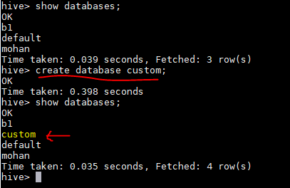

hive> CREATE TABLE temperature_data

> (

> full_date STRING,

> zip INT,

> temperature INT

> )

> ROW FORMAT DELIMITED

> FIELDS TERMINATED BY ',';

> FIELDS TERMINATED BY ',';

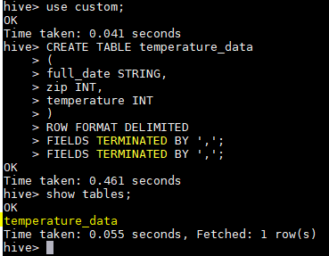

hive> LOAD DATA LOCAL INPATH '/home/acadgild/hive/dataset_Session14.txt'

> INTO TABLE custom.temperature_data;

